A Child’s Drawing Analysis
Katelyn Kinney
University of Missouri, Columbia

A Child’s Drawing Analysis
The purpose of analyzing the piece of artwork of a kindergartener was to see what stage that she is in and how artwork progresses. Children develop different abilities overtime and as they grow older, their artwork becomes more and more defined. Some children believe that they cannot draw well so they don’t really try. This young girl, however, loves to draw. She prefers to work in the art area during her free time so that she can make very detailed pictures. Being a teacher, it is very important to figure out what stage of development that your students are in. This is important because then you can plan your lessons around them in order to accommodate the students and their abilities. “It is important for art teachers to understand how children develop artistically. This kind of knowledge is essential for choosing age-appropriate teaching strategies and content for the units and lessons that the art teacher develops” (Luehrman & Unrath, 66). Teachers help students to grow in their artistic abilities and in order for them to do that, they need to figure out where students are in those abilities.
There are six different stages that a child goes through with their art. The stages are the Scribbling Stage (age 2-4), the Preschematic Stage (age 4-7), the Schematic Stage (age 7-9), the Gang Age (age 9-12), and the Pseudo-Naturalistic Stage (age 12-14), and the Adolescent Art (age 14-17) (Brittain & Lowenfeld, 474-479). These are known as the Lowenfeldian Stages of Art. Each stage represents different drawing characteristics, space representation, and human figure representations to help decipher where a student is in their artistic abilities. In this paper, I have chosen a drawing from a student in my field class and will discuss where I believe she is in her artistic development. I will analyze her drawing and discuss what the picture represents.
Description and Analysis
The drawing that I chose to use was from a kindergartener named Sarah (pseudonym). The drawing has many different colors on it and seems to be a picture of a girl outside with butterflies (see picture below). The girl seems to be holding something that looks like a balloon. Sarah scribbled the sky blue and purple at the top of the page and put a sun in the middle of the page. She made green scribbles down on the bottom to make grass. She made herself blue and is holding something connected to a string. She drew herself with curly hair and what looks like to be a scribbled on dress. She has stick arms and stick legs without hands or feet. There are many different purple butterflies in the picture. Some of them are colored in and some are not. The butterflies each have wings and a circle head. I watched Sarah as she drew this picture and after she was done she told me that she drew herself catching butterflies. She has written a series of letters down at the bottom of the picture to try and explain what her writing is. 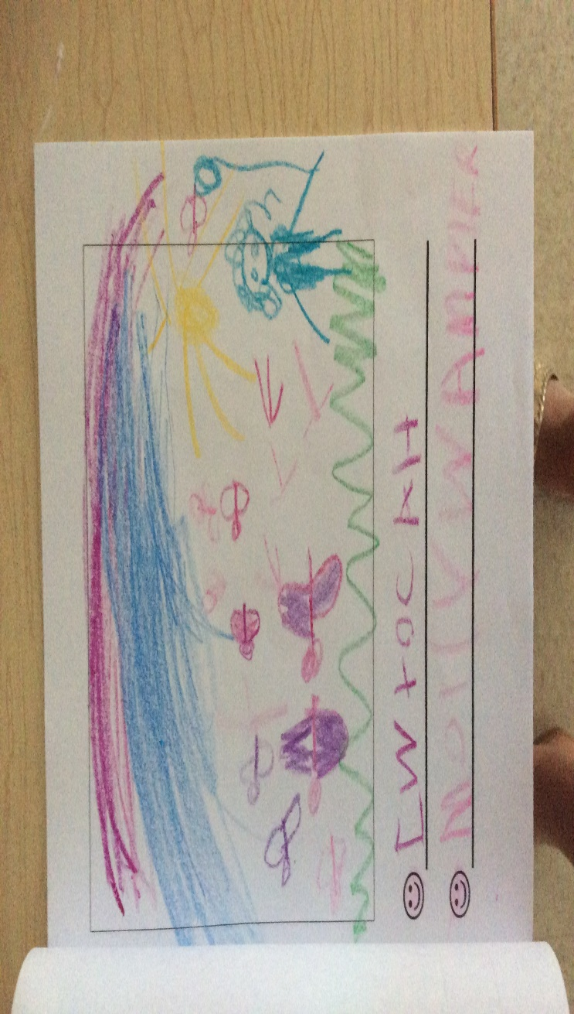
I believe that Sarah is in the Preschematic Stage of the Lowenfeldian Stages of Art. Sarah’s picture meets many of the drawing characteristics that represent this stage. The shapes in her drawing are geometric and if you took the butterflies out of the picture then you wouldn’t know what she is doing. The sun and grass are both placed in the correct places across the paper. For the human figure representation, she accurately drew hair on the figure as well as what seems to be a shirt.
The authors would most likely agree that Sarah is in the Preschematic Stage because of overall drawing. Although it is clear that she is between the age of four and seven because she is in kindergarten, she matches many of the characteristics for this stage. The only thing that she doesn’t really have is the inclusion of fingers, toes, hands, or feet. She never really rotated the picture whenever she was drawing and sometimes just scribbled to get that part of the picture done with. “Twenty Basic Scribbles are the building blocks of art, and they are important because they permit a detailed and comprehensive description of the work of young children” (Kellogg, 15). I think the authors would also enjoy how many colors that she used in her picture. Instead of just using one or two colors, Sarah used four different colors. Her teacher encourages them to use four or five colors in their drawings so that they are abstract.
Conclusion
For this child, my findings show that she is on the right track for what stage she should be in. Children between the ages of four and seven should be in the Preschematic Stage. Sarah is six years old so within the next year or two she should be moving into the Schematic Stage of the Lowenfeldian Stages of Art. As an education teacher, I want to encourage growth in my classroom by not limiting the students. By this, I mean that I want my students to do whatever comes to their mind as long as they can explain what they drew and why they drew it. I want them to experience their ability to draw by just creating whatever comes to their mind. There will be many days that I want my students to draw what they are thinking about and draw the picture however they want to even if it doesn’t make sense. I want to praise all of my students on their hard work and excellent artwork even if it isn’t what I asked for in regards to the lesson.
My investigation shows that art development is an important part of a child’s learning. As long as the teacher works with the students, then they will progress through the Lowenfeldian Stages of Art like they are supposed to. A child’s ability to create what they want is what helps to encourage them to try new things. “The arts help children learn to say what cannot be said” (Eisner, 2002). When a teacher is supportive of how a child is developing artistically then it can help the student to become more comfortable in stepping out of their comfort zone with the pictures that they end up drawing.

References
Eisner, E. (2002). The Arts and the Creation of Mind, In Chapter 4, What the Arts Teach and How It Shows. (70-92). Yale University Press.
Kellogg, R. (1970). Analyzing children’s art. Palo Alto, CA: National.
Lowenfeld, V., & Brittain, W. L. (1970). Creative and mental growth. New York: Macmillan.
Luehrman, M., & Unrath, K. (2006). Making theories of children’s artistic development meaningful for pre-service teachers. Art Education, 59(3), 6-12.

